MAGESH KUMAR  Mobile: +91 9972739101/ +91 8553269450 E-Mail: mageshnair739@yahoo.co.in  Flat No 934 Jal Vayu Towers, NGEF LAYOUT, INDIRANAGAR PO  BANGALORE KARNATAKA PIN 560038 | 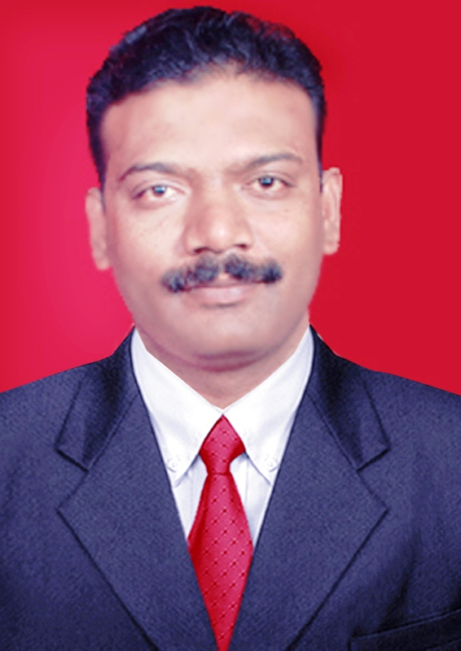
CAREER OBJECTIVE
To obtain Facility Manager position and to contribute to the success of the company. 20 years of extensive experience in the Indian Air Force as Senior Non Commissioned Officer. Expertise in Facility Management, General Administration and Security Crisis Management.

CAREER SUMMARY
SKILL SET
- Operation Management

- Property and structure & Lease agreements

- Inventory and Condition
Assessment

- Life Cycle Management

- Results Driven

- Leading People

- Ability to manage House Keeping, Security Service, Water Supply, Power Supply, Fire Fighting system and Horticulture.

- Expertise to manage property and structure by service level agreement and lease contract.
- Well versed in documentation and chart the processes used to operate the facility and provide services.

- Knowledge of Life cycle costs reviewing and comparing with current operating budgets.
- Ability to make timely and effective decisions and produce results through strategic planning and the implementation and evaluation of programs and policies.
- Ability to communicate, interpersonal skills and influencing and negotiating

CAREER ACCOMPLISHMENTS

- Awarded Best Airmen of the year -2006 by Station Commander, 26 Wing, Air Force for exceptional contribution during all events and missions.

- Commended by Station Commander 507 SU Air Force during 2009 for effective mentoring of non public funds (Airwarriors welfare fund) and settle all audit observations.

WORK EXPERIENCE

SNOC IC Administration and Discipline 26 ED, AF From: DEC 11 to TILL DATE

- Maintaining general discipline among the Depot personnel and implementing staff welfare policies with key focus on enhancing employee motivation.
- Detailing of manpower for various station secondary duties without compromising with their prime duties.
- Imparting on-job training to new staff, both at office and in the field.
- Developing & implementing budgets & annual plans for creation and maintenance of infrastructure as per organizational needs
- Planning & controlling of all cost elements of facility management with responsibility of establishing & managing cost improvement programs & other productivity programs.
- Supervising setting up infrastructure; networking with contractors for discussing, finalizing & completing the infrastructure requirements, in line with business requirements.
SNCO IC SHIFT AT TRANSPORTATION SQN 26 ED AF From: DEC 10 to DEC 11
- Manipulated the manpower and material handling devices to carry out loading and offloading of airborne items including Aero Engine well in time from various modes of transports as per the standard operating procedures.
- Ensured that the crew was following flight safety discipline both at service aircraft as well as Aircraft maneuvering area.
- Motivated the crew during heavy fatigues work.
Significant Achievements
- During the entire year there were no incidents/accidents of men as well as materials at Transportation Sqn.
- Motivated Logistic branch young air warriors to participate in inter branch sport meet and various station activities, results Logistics branch become overall champion during that calendar year.

SNCO IC SI FUND/NON PUBLIC FUND AT 507 SU, AF From: OCT 08 to OCT 10
- The management of hassle-free functioning of various non-public ventures including supervision of accounting and auditing.
- Organizing corporate events, felicitation ceremonies, conferences and related activities,
- Monitoring qualitative and quantitative standards of the ventures.
- Organizing various budget and audit conferences, audit presentations, etc., which demanded high level of diligence, planning and coordination.
- Maintenance and upkeep of accounting and auditable documents, processing of bills & vouchers and payments to the various agencies & contractors.
- Overall in charge of inspection bungalow maintenance.
Significant Achievements

- Ensured timely procurement of provisions and vegetable items at the station-run Departmental store, which is being the life line for personnel at remote location.
- Growth rate of SI Fund changed from negative to positive during the audit board at 2009-10.
- Monitored property of SI fund and handed over it without any discrepancies.

SNCO IC SANISTATION /ACCOMADATION IC at 26 Wing, AF May 2004 Oct 2008
- House keeping the station area by work force, supervising the casual labours and unskilled workers,
- Preparation and collection of pay rolls, and distribution of wages as per the laid down policies.
- Organizing corporate events, felicitation ceremonies, conferences and related activities.
- Accompanying the medical inspection team during the routine hygiene inspection settle the observation in time.
- Providing accommodation to the personnel arriving on transit to station at any given time and ensuring their comfortable stay at the station.

Significant Achievements
- At IIT Mumbai’s TECHNOFEST-2007, I was actively involved in to commissioning of Air Defense Elements enclosures at the fest and effectively maintained enclosures and promoted awareness among young engineers. This has been appreciated by The Commanding Officer

TRAININGS /CERTIFICATIONS ATTENDED
English Typewriting Junior Karnataka Secondary Education Examination Board
PC Package course (Win 95 & MS Office) at DIT Air HQ
PC Programming course (Visual Basic 6) at DIT Air HQ
Network & System Administration at DA- IICT Gandhinagar
23 Basic Fire Fighting Course at AFS Tambaram
No 32 Composite Basic NBC (Nuclear, Biological and Chemical Warfare) Indoctrination course at AFINBC Protection
Undergone VTC Course conducted by CII under expert senior professionals.

EDUCATION
Academic:
Pursued and obtained BBA through Mudrai Kamaraj University during the academic period 2008-2011
PROFESSIONAL SKILLS
- Windows 7.0, Professional, MS Office, VB6, Network and System Administrator
EXTRACURRICULARS
- Hand Ball
- Event management activities
PERSONAL DETAILS
Date of Birth: 14 Jan 1974
Languages Known: English, Hindi, Tamil, Malayalam and Kannada

